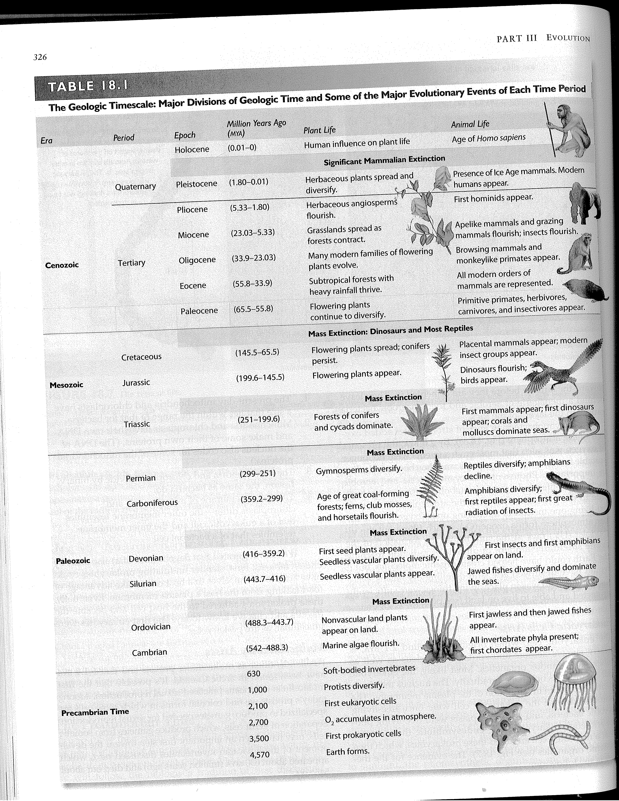
Bio Project – Geological Timeline: Work with your group members at your table to make a timeline showing the Geologic Time Scale (history of the Earth) and the major biological events that happened through time as shown in Table 18.1 below from Biology, 10th Edition, by Sylvia S. Mader. Note the numbers below are in “million years ago”. That means that 1 actually = 1,000,000 (1 million) and 1,000 actually = 1,000,000,000 (1 billion). Use the scale of 1 inch = 50 million years to draw your timeline. That means your timeline will span 9-10 sheets of paper. Please tape the sheets together to make one continuous timeline without any breaks. 1) Below the timeline, accurately label the Epochs, Periods and Eras. 2) Above the timeline identify the type of plant life and animal life that existed during those Epochs, Periods or Eras. 3) On/Above the timeline identify when the six major extinctions occurred. Your group’s timeline will be graded on accuracy, neatness and completeness. 4) Optional: You may decorate the timeline with the representative pictures as shown in the Table below. Please write you and your partner’s names neatly on the front, bottom right corner when complete.

Geological Timeline Project Your Names:_____________________________________

Complete/Ontime | 10 | 8 | 6 | 4 | 2 | 0
Names/Neatness/Creativity |  | 7 | 5 | 3 | 1 | 0
Proper Scale |  |  | 5 | 3 | 1 | 0
Eras/Periods/Epochs | 10 | 8 | 6 | 4 | 2 | 0
Mass Extinctions | 10 | 8 | 6 | 4 | 2 | 0
Major Evolutionary Events | 10 | 8 | 6 | 4 | 2 | 0

Total = ______/50

